What is maven?

Maven is a powerful project management tool that is based on POM (project object model). It is used for projects build, dependency and documentation.

\*Steps to configure maven :

1) go in help🡪install new software

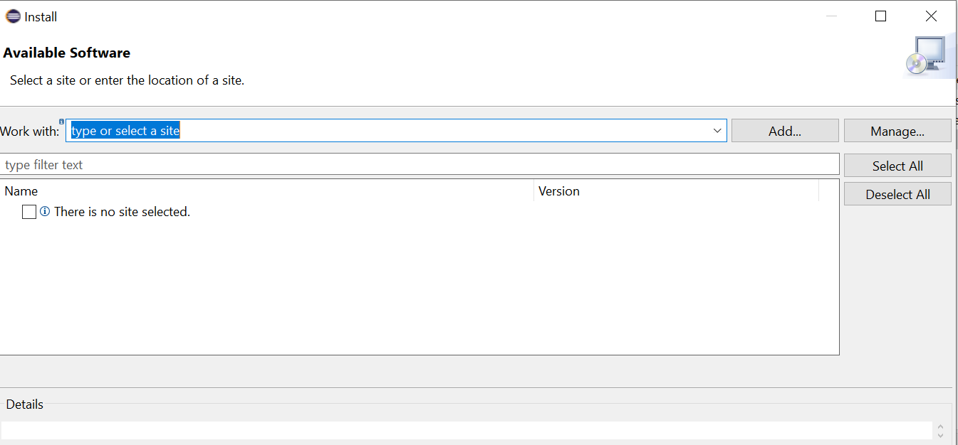

2)add name and location and then add

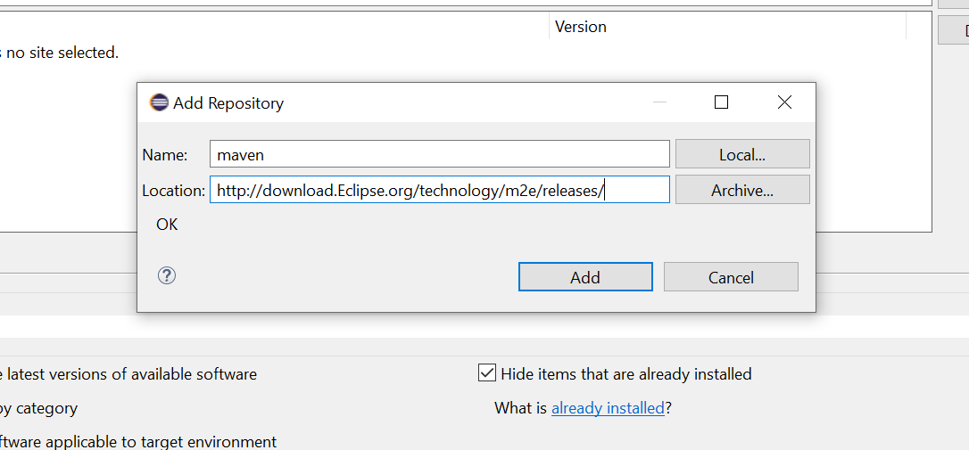

3)check box maven integration for eclipse and then next

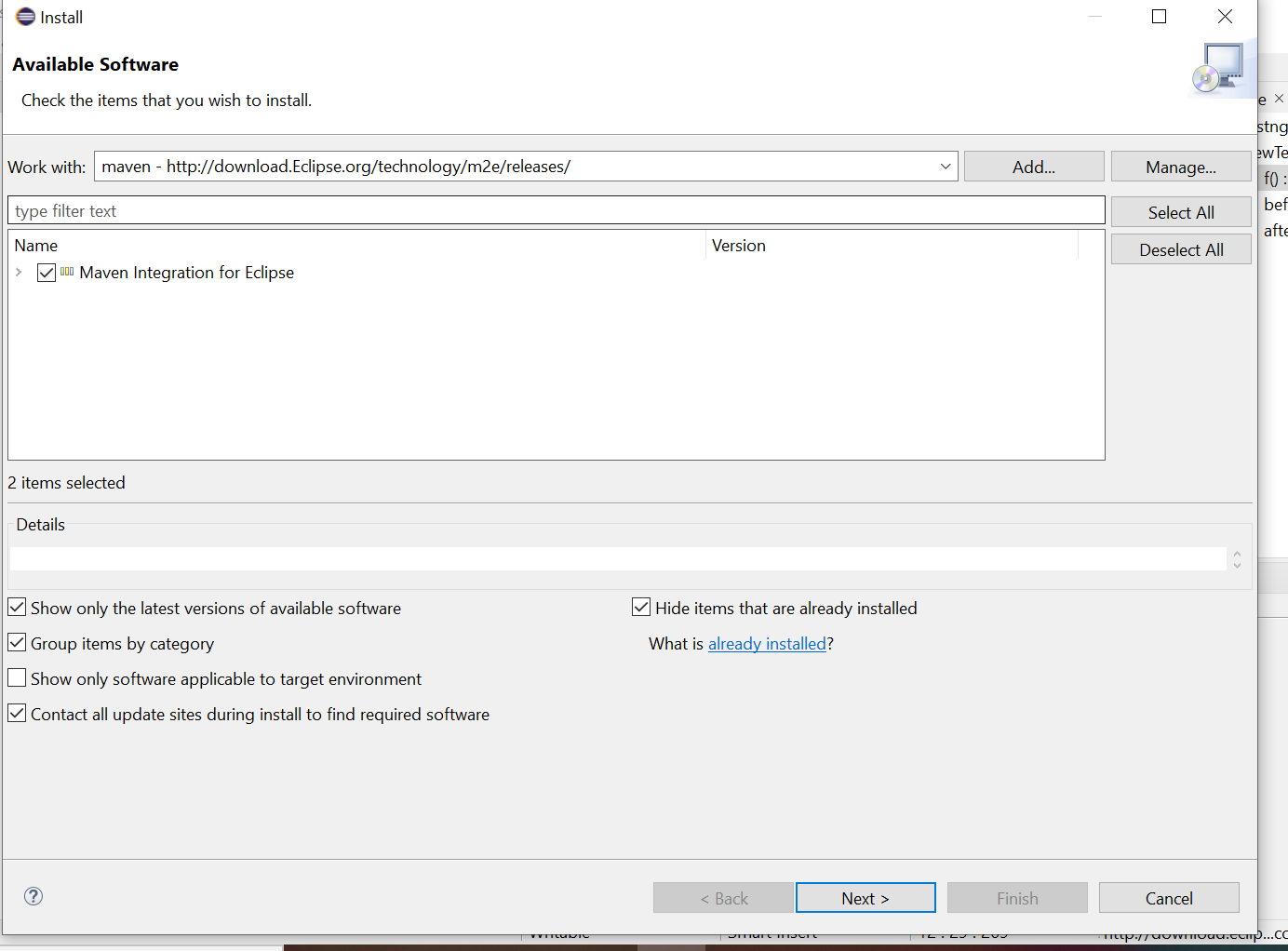

4)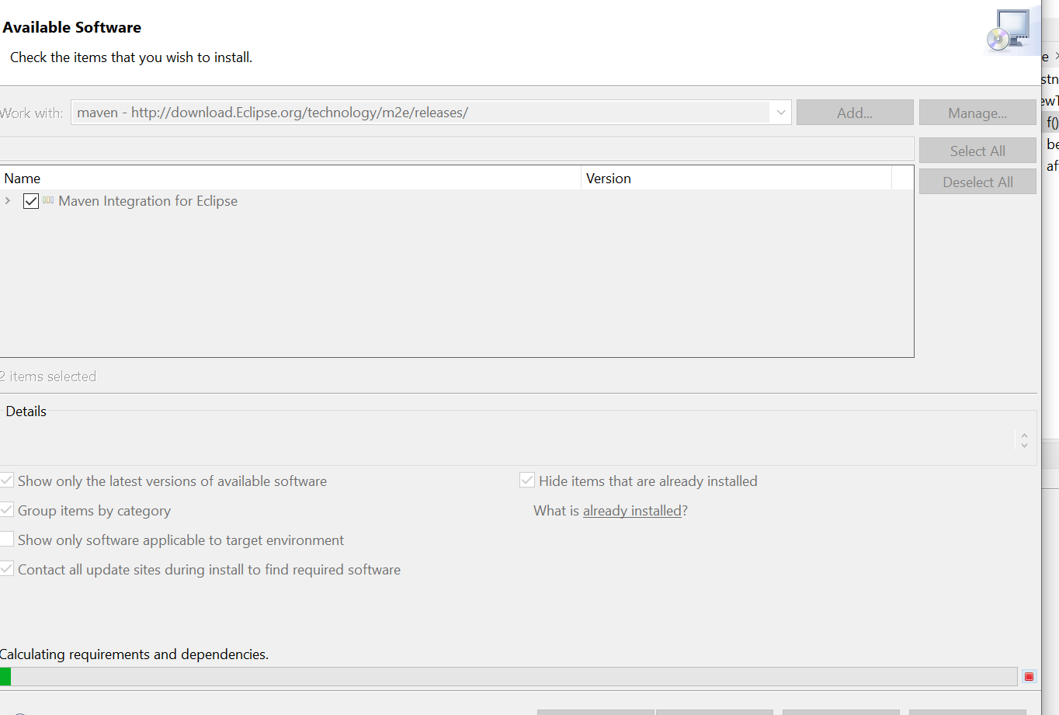

5)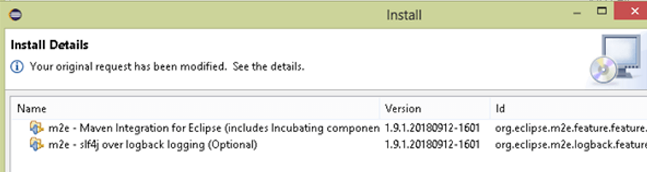

6)Accept licence agreement

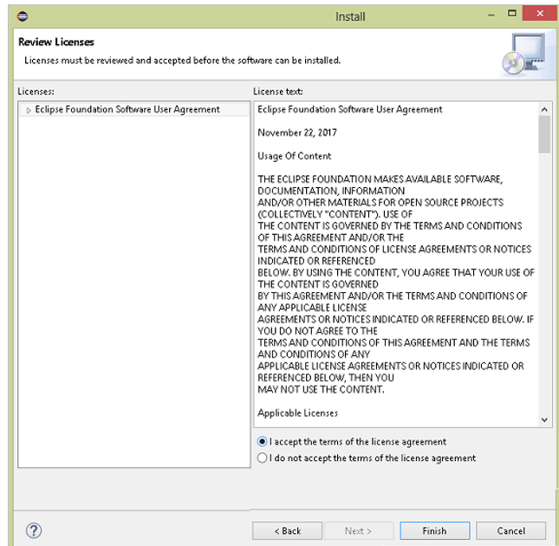

7)then restart eclipse

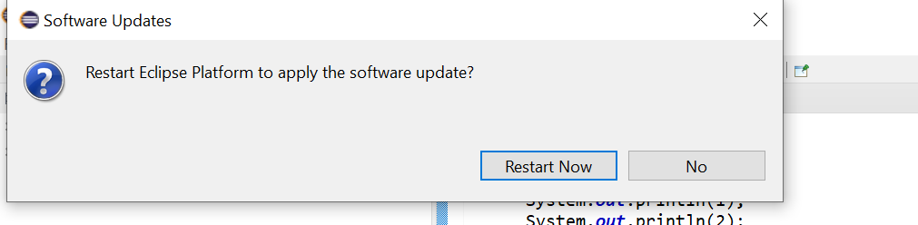

8)then file->new project->maven project

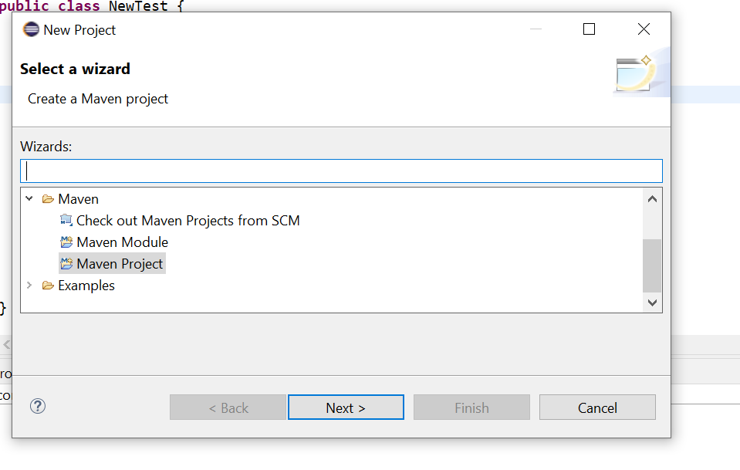

9)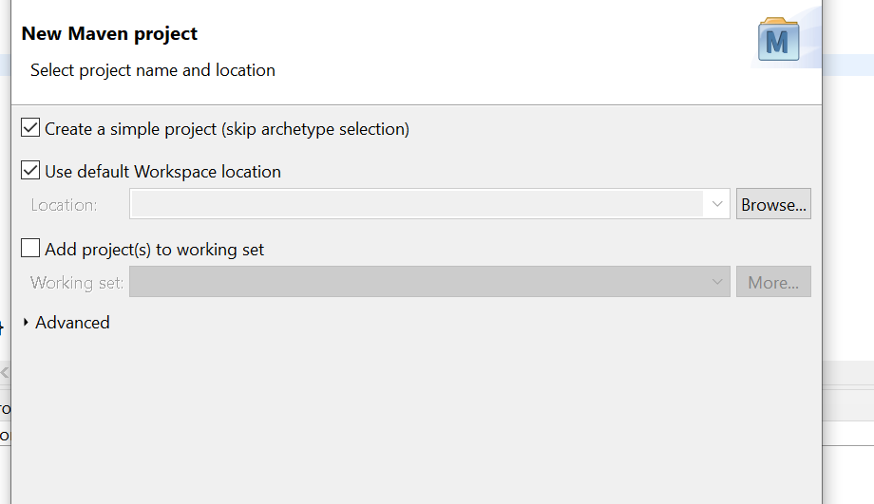

10)type group id and artifact id and then finish

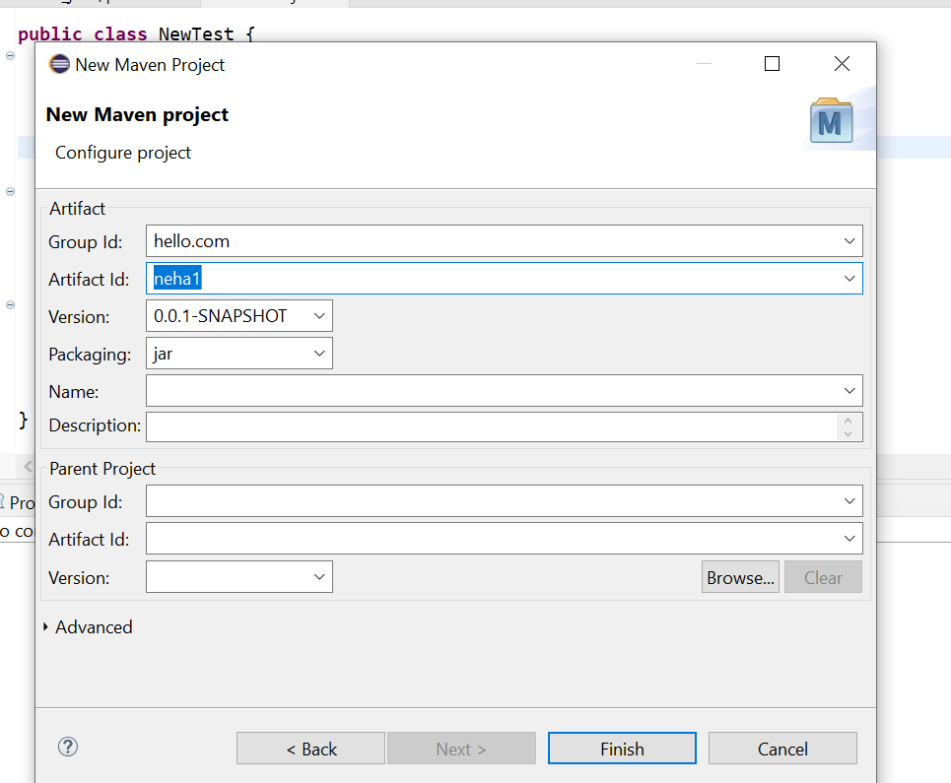

11) after finishing we get to see pom .xml and we can add dependencies in it

